Blue Ocean Strategy

Recap
- Network effects kickstart when a critical mass is reached, leading firms to compete on market share. Metcalfe’s Law is that the number of unique connections in a network is n(n-1) / 2, and hence value increases exponential with n. Network effects:
  - Raise barriers to entry when incumbents have large networks
  - Creates higher and higher switching costs
- Netflix – credible threat of entered suppliers (game companies) terrorist could allow them to bully game developers into releasing on Netflix
- Amazon gives you one login for many different services to fully harness network effects
- IBM’s product was inferior to Apple’s, but it was a bigger platform so it harnessed network effects – more developers, more users, etc.

What is a Blue Ocean strategy?
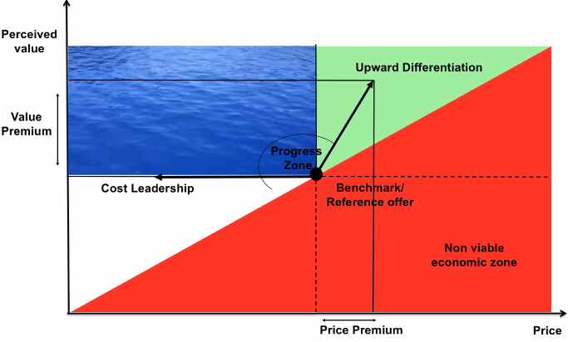
- Blue ocean strategies challenge assumptions and cross boundaries. One example is by achieving cost leaderships but at a high value
  - Airbnb seem to have broken the price and value trade-off, being both cost leaders and differentiators, helped by their lack of fixed costs. Hotel industry’s reaction was trying to push for regulation on Airbnb on a safety basis, hoping for scandals but the rating system is a robust mechanism.
    - Hotel category had certain expectations, Airbnb creates new category
- Apple shifted product-based competition to platform-based competition.
- Kodak created a new market, utilising the Kodak moment.

Developing a Blue Ocean strategy
- Look across alternative industries and look to fuse your offering with theirs, adding parts of their competitive mix to your own.
  - Cirque du Soleil fused the circus industry with the theatre industry

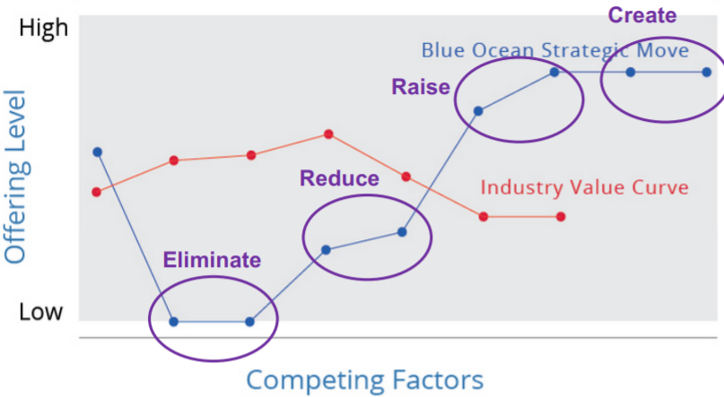
- Strategy canvass of competing on different factors to what the industry currently is using the eliminate, reduce, raise and create framework
- Ikea implemented Blue Ocean strategy by eliminating the factor of providing support through assembling furniture
  - Challenged the assumption that customers desire this – furniture are not heirlooms anymore
  - Challenged the assumption that people have specific tastes and want furniture to be durable.
- Hard for firms to challenge Ikea as they would have to abandon their brand image. Ikea already has scale and the market share, with a streamlined supply chain
  - Cheap meatballs solidify the brand image and serve as a meeting place for customers and businesses. They make a loss on the meatballs to achieve this.
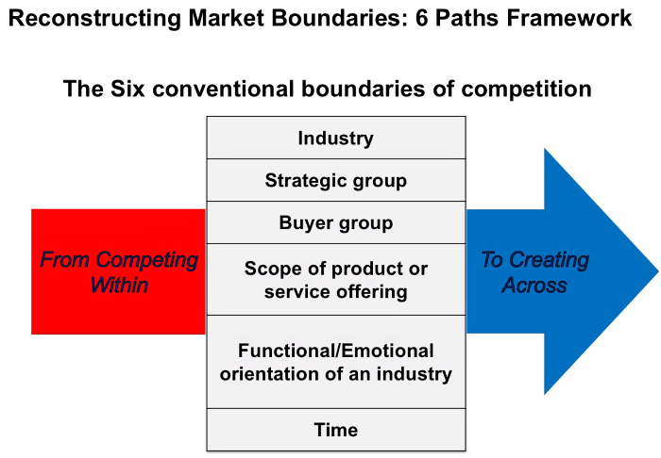
- This strategy canvass can be applied when comparing our offering to others’ in our strategic group and when assessing our different buyer groups
  - F1 toying with different factors to combine 2 star comfort attributes with 1 star prices by introducing self-check-in, removing eating facilities and 24h reception etc
- Buyers and strategic groups.
  - Buyer group is who are you selling to. Possible to find a new buyer group e.g., autonomous vehicles, who have different desires of offering factor levels
  - Ryanair eliminated add-ons of flights

- Functional and emotional appeal – add emotion to stimulate new demand in a functionally orientated industry e.g. Swatch encouraged multiple watches in different colours, made it a fashion item
  - Alternative – strip away extras from an emotionally oriented industry to offer a functional, simple, low-cost model
- Look across time – play with how your product is consumed across time. Key principles for assessing time trends are that the trends should be decisive and have a clear trajectory, should be observable today so that we can participate in shaping its future.
  - CNN first 24 news channel, introduced the concept of breaking news.
  - Netflix added the convenience of allowing you to binge TV shows

Implementing a Blue Ocean move
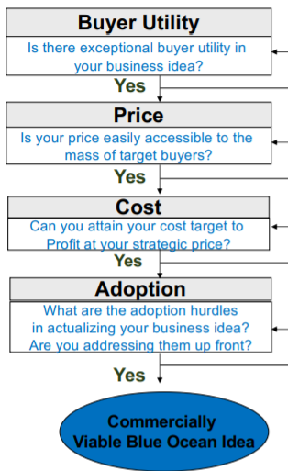

Logic behind Blue Ocean
- Its not about tech innovation, often the underling tech already exists
- You don’t have to venture into distant waters – most strategies come from within the existing industries, with incumbents creating Blue Ocean within their core businesses.
- Never use the competition as a benchmark. Instead, create a leap in value for customers by making competition irrelevant
- Reduce costs whilst also offering more value

Imitation barriers to Blue Ocean Strategy
- Cognitive barrier
  - If value innovation doesn’t make sense to a company’s conventional logic
- Brand barrier
  - Companies who value innovate earn buzz and a loyal customer following who then tend to shun imitators
  - Blue Ocean strategy may conflict with the imitator’s brand image
- Intellectual property barrier
  - Where initiator patents their innovation e.g. Dyson
- Economic barrier
  - Network externalities can discourage imitation e.g. Netflix
  - High volumes lead to rapid cost advantage e.g. Swatch

Characteristics of a good Blue Ocean strategy
- Focus – a company’s strategic profile, or value curve, should have a clear focus.
  - Do not diffuse efforts across all factors of competition, emphasise a few
- Divergence – reactive strategies tend to share the same strategic profile, or value curve
  - Divergence is achieved by not just benchmarking against competitors, but instead looking across alternatives
- Compelling tagline – a clear message and also advertise the offering truthfully, else consumers will lose trust and interest

Summary
- Don’t compete – make competition irrelevant using focus, divergence and a compelling tagline
- Break the value-cost trade-off using the 4 actions framework (eliminate, reduce, etc)
- Reconstruct market boundaries using the 6 paths framework
- Assess the 3 tiers of non-consumers and find commonalities
- Keep the Ocean blue by creating cognitive, brand and economic barriers

- Fine to tell them about a way to transcend the disruption

- Base it in covid times, how has this affected the balance between Airbnb and covid industry. How can they transcend the disruption of covid. Lockdown ending is a new start – how can you capitalised on the new fears and sensitivities. Convince that I understand the situation and have analysed the situation, then can make recommendations without data.

  - Ghost kitchens where there is one kitchen for loads of restaurant brands – Deliveroo system

Reading

Blue Ocean Strategy HBR (Kim and Mauborgne, 2004)
- Despite long-term decline in the circus industry, Cirque du Soleil has increased revenue 22-fold by reinventing the circus in a Blue Ocean strategy which saw them develop uncontested market space rather than compete within the confines of the existing industry.
  - Red oceans are industries in existence where boundaries are defined and accepted
  - Blue oceans are industries in which demand is created, not fought over. This occurs as new industries are created or, more often, the boundaries of an existing industry are altered
  - Over the past 100 years, more than 150 blue oceans have been created in over 30 industries, usually with a consistent pattern of strategic thinking.

Pattern of strategic thinking
- Blue oceans are not about technology innovation, rather linking existing technology to what buyers value, sometimes against common industry wisdom.
  - Ford’s assembly line use technology from the meat-packing industry
- Incumbents often create Blue Oceans and usually within their core offering. Most Blue Oceans are created within an existing industry
- Company and industry are inappropriate units of analysis. The strategic move, i.e., the set of management decisions and actions involved in creating a new market is the most appropriate unit of analysis.
- Creating Blue Oceans build brand equity that last for decades

Defining characteristics
- Creates uncontested market space
- Makes competition irrelevant
- Create and capture new demand
- Break the value/cost trade-off
  - Cost savings made by eliminating and reducing currently accepted competitive factors
  - Buyer value increased by introducing new elements the industry didn’t offer
  - Cirque du Soleil didn’t follow the red ocean logic of offering more fun and thrills, they dropped high-cost animal acts, kept the acrobatics and followed storylines and themes with tailored music and lighting etc. Achieved differentiation and low costs
- Align the whole system of a company’s activities in pursuit of differentiation and low cost

Kim and Mauborgne, 1999
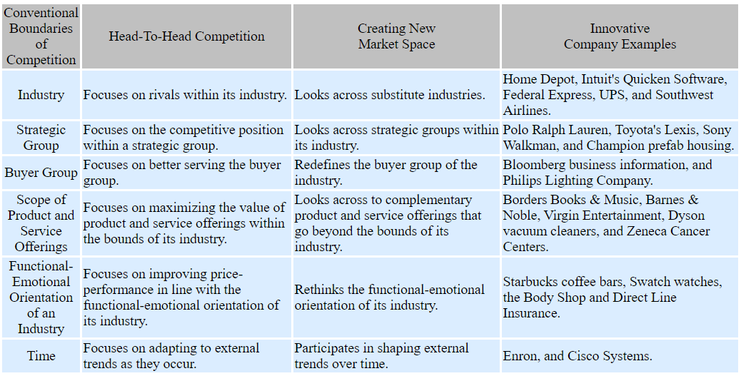
Creating new market space: a systematic approach to value innovation can help companies break free from the competitive pack

Looking across competitive industries
- Companies compete with companies that offer substitute products as well as companies within their own industry. The space between substitutes provides opportunities for value innovation.
  - Home Depot created a market of DIYers in the space between choosing contractors and going to the hardware store.
- New opportunities like this can be discovered by offering the following questions and subsequently creating a different value curve:
  - Reduce: what factors should be reduced below the industry standard?
  - Eliminate: what factors that the industry takes for granted can be eliminated?
  - Raise: what factors should be raised above the industry standard?
  - Create: what factors that the industry has never offered can be created?

Looking across strategic groups within industries
- Strategic groups refer to companies within the same industry pursuing a similar strategy
- Rather than competing within a strategic group, value innovators create new market space by understanding what causes buyers to trade up or down from one group to another.
  - Sony Walkman provides the cool image of a boom box with the low price and convenient size of a transistor radio.

Looking across buyer groups
- Rather than looking at a target customer, value innovators pursue the chain of customers that includes purchasers, users, and influencers.
  - Philips Lighting shifted emphasis from purchasers to influencers by producing the an environmentally friendly light bulb that it promoted to CFO's and PR people.
  - Product sales grew rapidly as traditional fluorescent lamps that contain toxic mercury were replaced in schools, stores, and office buildings.

Looking at complementary offerings
- Value innovators also tap hidden opportunities by defining the total solution that buyers seek. The idea is to think about what happens before, during and after your product or service is purchased. Similar idea to vertical integration but just change the offering
  - Barnes & Noble created book superstores to provide a holistic lifelong learning experience, with books, armchairs, knowledgeable staff etc

Looking at functional and emotional appeal to buyers
- Starbucks introduced a new concept - the coffee bar, to provide coffee drinkers with an emotional experience rather than just a cup of coffee.
- Can you make an emotional product more functional, or a functional product appeal to the buyers’ emotions?

Looking across time
- To develop a new value curve, the temporal trend must be decisive to your business, irreversible, and have a clear trajectory.
  - Cisco Systems created new market space after identifying a trend that satisfied these principle – the growing demand for high-speed data exchange. Cisco crated break-through value by producing routers

